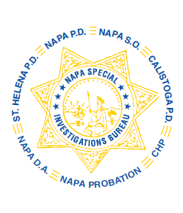
NAPA SPECIAL INVESTIGATIONS BUREAU
GOVERNING BOARD

OPEN MEETING AGENDA

Time/Date: Thursday July 24, 2025

Place: Napa County Sheriff’s Office

Memo to: Members of the public

Allison Haley, District Attorney, Napa County
Chris Hartley, Chief of Police, St. Helena
Fabio Rodriguez, Chief of Police, Napa
Amanda Gibbs, Chief, Napa County Probation Department
Matthew McCaffrey, Chief of Police, Calistoga
Michael McClellin, Captain, California Highway Patrol
Ryan Woolworth, Lieutenant NSO/NSIB

From: Oscar Ortiz, Sheriff, Napa County, Governing Board Chair

Call to order: Roll Call

Agenda items:

- Public Comment. During this time period anyone may comment to the Governing Board regarding any subject over which NSIB has jurisdiction, or request consideration to place an item on a future agenda. If you wish to comment on an item that is on this agenda, please hold your comments until the item is heard. Individuals will be limited to a three-minute presentation. No action can be taken by NSIB as a result of public comment other than to act to place the matter on a future agenda.

- Approval/Correction of the March 27, 2025, Meeting Minutes – GB Chair

- NSIB Statistics

- NSIB MOU discussion/update

- Cope Family Center

- Open Discussion
- Adjournment

